Meld Quickstart Guide

Contents

Meld Overview 3

What is the Meld Sandbox? 3

What is InterOp.Community? 3

Introduction to FHIR 3

What is FHIR? 3

Why is FHIR Important? 3

How FHIR Works 4

Other FHIR Initiatives 4

Getting Started with Meld 4

Creating an Account 4

Logging In 4

Site Navigation 4

Creating a New Sandbox 5

Importing and Exporting a Sandbox 5

Navigation Bar 6

Sandbox Settings 6

Editing Your Account Details 7

Exploring Meld 7

Accessing the FHIR Resources 7

Patient Data Manager 7

Personas 8

Utilizing the Sandbox Tools 9

Apps Page 9

**Manual Registration** 9

**Manifest Registration** 10

Bilirubin Risk Chart Application 11

CDS Hooks Application 11

EHR Simulator 12

Registering a CDS Service 12

Launch Scenarios 12

Tools 13

Validation 13

Appendix: Terminology 14

# Meld Overview

## What is the Meld Sandbox?

Meld is an open-source healthcare sandbox populated with fully synthetic FHIR® data. It provides a safe space for creation, development, testing and validation of healthcare applications and APIs. The fully synthetic data existing in Meld allows for users to “fail forward” when working with the data, as there is no risk of PHI or PII exposure.

## What is InterOp.Community?

Interop.Community is a not-for-profit health IT community focused on the leveraged use of open-source software to provide industry test-beds, “sandbox” environments, technology incubation, and HIT platform and resources to promote health, human services, and wellness via interoperability.

**Why is it relevant?**

InterOp.Community is the steward of the Meld sandbox. The Meld sandbox is a proving ground for collaboration, innovation, creation, and validation.

**What do they do?**

The community is organized under an Advisory Board, with an Operations arm and a set of workgroups focused three key focus areas:

* The Codebase is an open-source cloud-hosted sandbox being applied to public good needs.
* Proving Grounds that are publicly visible with no PHI, no user fees sponsored by I.C where 3rd party contributions are accepted (COTS)
* Private Lockers that offer and extend the features of the Proving Ground options, with extended service levels and enhanced privacy/visibility controls.

**How can you get involved?**

You can go to the InterOp.Community website for more information on the InterOp.Community or email info@interop.community to reach out directly.

# Introduction to FHIR

## What is FHIR?

Health Level Seven International (HL7) is a not-for-profit organization that develops and standardizes the data framework for the exchange of electronic health information. One set of these standards is Fast Healthcare Interoperability Resources (FHIR).

## Why is FHIR Important?

FHIR is designed to help health information organizations quickly and easily retrieve and exchange data from EHR systems. Health IT developers use the standard to efficiently build applications for data exchange.

## How FHIR Works

FHIR frameworks are built around the concept of Resources. Resources are basic objects or modular units that can be assembled into working systems. These systems resolve clinical, administrative and infrastructure problems in healthcare.

Administrative concepts (e.g., patients, providers, organizations, and devices) as well as a variety of clinical concepts (e.g., conditions, medications, diagnostics, care plans, and claims information) are translated into FHIR Resources.

FHIR is designed specifically for the web with Resources and foundations in two formats: XML and JSON. The Resources use structured and standardized data for easy interoperability between EHR vendors and other software development resources and tools. More information on FHIR can be found at: https://www.hl7.org/fhir/overview.html

## Other FHIR Initiatives

SMART on FHIR has also gained broad industry support. The SMART on FHIR initiative is based at Boston Children’s Hospital and features a set of open specifications to integrate apps with EHRs, portals, health information exchanges (HIE) and other health IT systems.

HAPI FHIR, otherwise known as Happy Fire, is a free, open-source Java implementation of the FHIR specification. It was developed at University Health Network in Ontario, Canada.

# Getting Started with Meld

## Creating an Account

To create an account for the Meld Sandbox, you will want to navigate to <https://meld.interop.community/>, you will be greeted with a Sign In page. To create an account, click the **Register** button.

Once you’ve clicked the **Register** button, you will be prompted to fill out several fields—**First Name**, **Last Name**, **Email**, **Username**, and **Password**. After filling out these fields, you’ll need to click the **Register** button, as shown below.

After registering, you will receive an email from the InterOp.Community email, which will allow you to verify your account.

Once your account has been verified, you will be free to spin up a new sandbox to use!

## Logging In

To Login to your Meld account, you’ll navigate to <https://meld.interop.community/> and input the email and password you used when you registered your account. Once you have input the information, simply click **Sign In** and you’ll be all set.

## Site Navigation

Upon logging in for the first time, you will be prompted to read and accepted the **Terms of Use**. After thoroughly reading the Terms of Use information, click **Accept**.

After logging into your Meld account, you’ll be directed to the **My Sandboxes** page. This page will contain information on all the sandboxes your account currently has access to.

You will be able to see the following information:

* FHIR Version of the Synthetic Data
* If the Sandbox has an Open or Closed Endpoint
* Name of the Sandbox

You also have the ability to organize your sandboxes based on the last sandbox you used or have them organized alphabetically.

## Creating a New Sandbox

You will be able to create new sandboxes from the My Sandboxes page. Start by clicking the **New Sandbox button**, this will open a pop-up which will allow you to input the necessary sandbox information.

You will need to fill out the following fields:

* Sandbox Name
* FHIR Version

Optionally, you’ll also be able to decide if you want the sandbox to have an Open or Closed endpoint, Import the sample patients and practitioners, and import the sample applications.

You can also add a sandbox description if you feel this will be helpful, but it is not required to create a new sandbox.

Once all the required fields and optional content have been added, you will simply need to hit the create button. This will begin spinning up the new sandbox.

Your new sandbox will be added to your list but will be greyed out until the sandbox spin up is complete. You will also see a loading icon on the far right of the sandbox list, with an estimated time until the sandbox spin up is completed.

Once your sandbox is spun up and ready to use, you will simply need to click on the sandbox name to open it and start using.

## Importing and Exporting a Sandbox

On the **My Sandboxes** page, you will find the ability to export or import entire sandboxes into your Meld account.

**Importing Sandboxes**

To import a sandbox, you will click on the Import Sandbox button.

This will open a pop-up which will prompt you to upload a .zip file. Select the .zip file which contains the sandbox you would like to import.

Once you have uploaded the .zip file, Meld will let you know that your sandbox import has started. After you receive this message, you will shortly notice that the sandbox you imported will appear in your sandboxes list with the loading icon next to it. Once the import has completed, you will be able to open your sandbox and use it as normal.

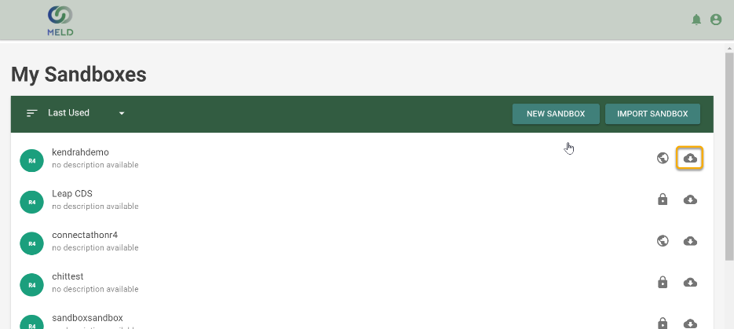**Exporting Sandboxes**

All sandboxes can be exported into a .zip file. To do this, users must simply click export icon that can be found on the right side of the **My Sandboxes** list. Once you have selected the export icon, a Pop Up will open letting you know to check your email for the .zip file. The .zip file should appear in your email shortly after the export has been completed and you will be able to download it for 48 hours after you receive the email.

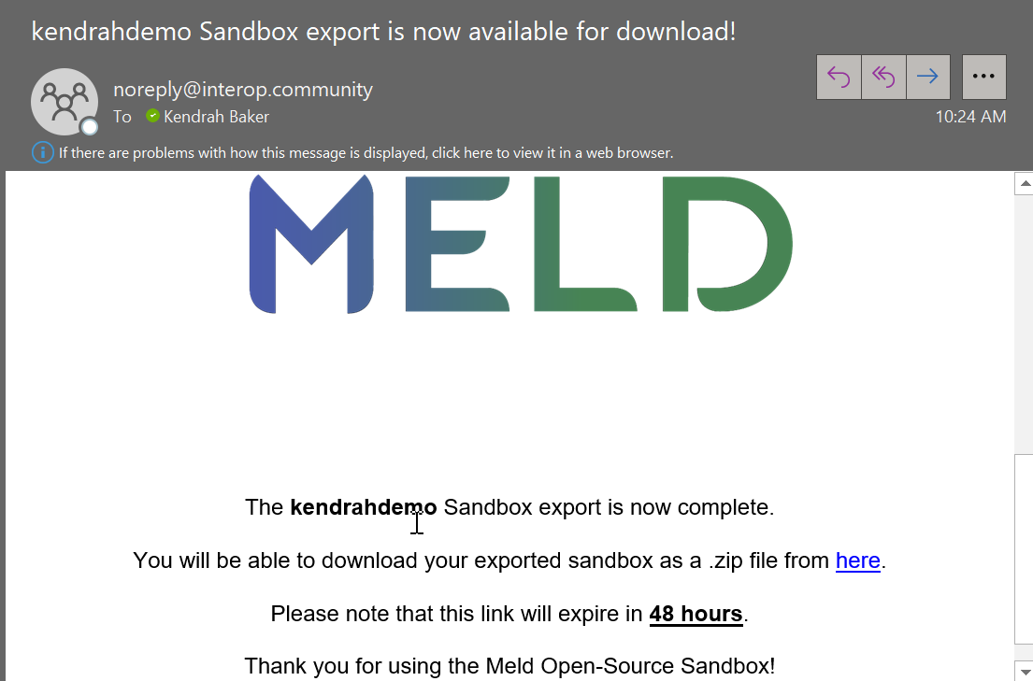

## Navigation Bar

Once you have entered your sandbox, you will find a Navigation Bar running along the left side of the sandbox page, these tabs will allow you to go to any of the pages within the sandbox. You will find tabs for the following pages:

* EHR Simulator
* Apps
* CDS Hooks
* Launch Scenarios
* Patients
* Personas
* Practitioners
* Profiles
* Data Manager
* Tools
* Settings

**Navigation Tabs**

The **Data Manager**, **Tools**, and **Settings** pages have additional navigation tabs within those pages. These run along the top of the page and allow the user to access additional content. Simply click on the navigation tab to access additional page content.

## Sandbox Settings

**User Settings—Add, Edit, & Remove Users**

Each sandbox has the capability of adding additional users. You can do this on the **Settings** page. Navigate to the **Users** page, and click on the **Users** tab. This page will allow you to manage all the users for this specific sandbox instance.

**Manage Invites** will allow you to see the status of invitations you have sent out and send out new invitations if needed. To send out an invite to a new user, just input their email address and hit send. The user will receive an email in their inbox to use the sandbox.

The **Export Users** button will export your sandbox users list into an Excel file which you can download to your computer.

The Import Users button will allow you to add multiple email addresses and send out multiple invites at one time. It will also allow you to import a CSV file which will send out invites to all emails within that CSV file.

**Editing Your Sandbox’s endpoints**

Each sandbox instance can have both an **Open** and **Closed** endpoint. In the **Settings** page, users can adjust the endpoint settings. By clicking the Edit icon in the top right of the **Settings** page, the user can check or uncheck the open endpoint option in the settings.

## Editing Your Account Details

**Changing your password in KeyCloak**

By selecting the Account Icon in the top right of the Meld sandbox, you will be able to select Account Settings and be taken to your Keycloak Account Settings page. Select Signing In under the Account Security section, this will take you to the page where you will be able to update your password. It will also show you when your password was last updated.

# Exploring Meld

## Accessing the FHIR Resources

Patients Tab

The Sandbox Patients is a listing of all the patients that are loaded into your Sandbox. You can add additional patients and can modify the demographic and clinical data for the patients using the link on the patient record or launching the Logica Patient Data Manager App.

## Patient Data Manager

The Meld Patient Data Manager app is a SMART on FHIR application that is used for managing the data of a single patient.

The app is available in the Meld Sandbox as a data management tool. The app allows a user to:

* Create/update demographic data
* Create/update/delete clinical data
* Provide data support for showcasing other healthcare apps
* Provide data support for showcasing CDS hooks apps
* Provide data support for showcasing backend systems

The Meld Patient Data Manager requires a patient to be in context. It can be launched from Sandbox Manager by selecting the Patients menu, selecting the desired Patient, then clicking the Open Patient Data Manager button.

**Edit FHIR Resources**

Select a resource on the left side of Patient Data Manager. Then select the desired Resource in the list in the center. A details pane will display on the right side. You can make modifications in the details pane and then save you changes by clicking the save icon on the top right of the details pane.

**Create FHIR Resources**

On the left side of Patient Data Manager, there is a list of supported FHIR Resources. When you select one of these resources, (with the exception of Patient) you will see a small + to the right of the Resource name. This + button allows you to create a new Resource of the given type. The modal dialog which opens to create a Resource gives you a list of the most common attributes for the Resource type. Fill in the desired values and click the Create button

**Delete FHIR Resources**

Select a resource on the left side of Patient Data Manager. Then select the desired resource in the list in the center. A details pane will display on the right side. You can delete the selected resource by clicking the ... (ellipsis) icon on the top right of the details pane and select Delete from the list.

**Clone a Resource**

Select a resource on the left side of Patient Data Manager. Then select the desired resource in the list in the center. A details pane will display on the right side. You can clone the selected resource by clicking the ... (ellipsis) icon on the top right of the details pane and select Clone from the list. The modal dialog which opens to clone a resource gives you a list of the most common attributes for the resource type pre-filled with the values from the cloned resource. Make any desired changed and click the Create button.

**Retrieve the JSON for a FHIR Resource**

Select a resource on the left side of Patient Data Manager. Then select the desired resource in the list in the center. A details pane will display on the right side. You can display the selected resource's JSON by clicking the ... (ellipsis) icon on the top right of the details pane and select JSON from the list. The modal dialog which opens contains the JSON for the given resource. You can select and copy the JSON from this dialog.

## Personas

A sandbox persona is a user used for authenticating when launching an app. A Persona is tied to either a Practitioner or Patient FHIR Resource.

**Create new Persona**

Step 1: Select who is the Persona (patient or practitioner) will be

* A Persona is used to simulate a real-world actor in an app launch. First, select either patient or practitioner. The practitioner icon is on the right, and the patient icon is on the left. Mouse over the icons to see their descriptions.Graphical user interface, text, application, email

  Description automatically generated
* If you select a practitioner, then you are creating a Persona which is tied to a practitioner to later be used to open an app and perform a function. If you select the practitioner icon, this pop up will appear.

* If you select a patient, then you are creating a Persona which is tied to a patient to later be used to log into a PHR or patient portal to perform a function. If you select the patient icon, this pop up will appear.

Step 2: Enter a user ID and password for the Persona

* Select a Persona from the list
* Enter a user ID and password to be used when authenticating the persona during the app launch.
* Note: the user ID will be postfixed with "@<sandboxId>

Step 3: Save

* Save the Persona by clicking **Create**. Now the Persona is available to be used in a Launch Scenario or for authentication during a standalone launch.

# Utilizing the Sandbox Tools

## Apps Page

How to register a new application

# **Manual Registration**

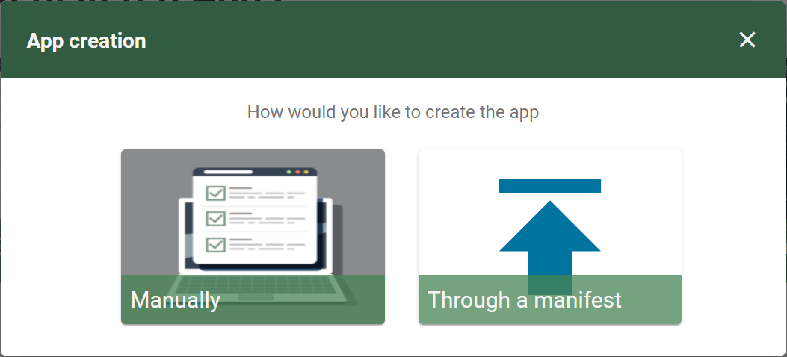

Step 1: Enter Information for Your App

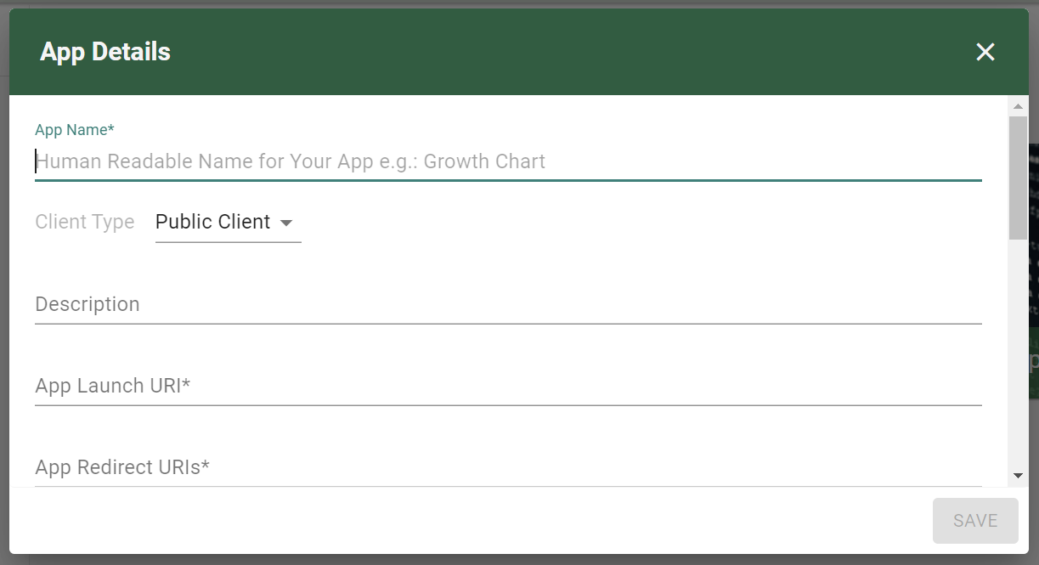

You’ll need to add the following information:

* App Name
* App Launch URI
* App Redirect URIs

Optionally you can also add the following information:

* Scopes
* Sample Patients
* Allowed Offline Access
* App Image

# **Manifest Registration**

Precondition: Create an App Manifest



A SMART app manifest is an emerging standard that allows an app to declare registration information within the app bundle or hosting. A registering system, such as a sandbox or HER, is able to use the manifest to dynamically register the app.

See <https://bitbucket.org/mihinss/registration/src/master/> for details.

**/.well-known/smart/manifest.json**

{

"software_id": "org.logicahealth.bilirubin:bilirubin-risk-chart:1.0-SNAPSHOT",

"client_name": "Bilirubin Risk Chart",

"client_uri": "https://apps.logicahealth.org/hspc-bilirubin-risk-chart/index.html",

"logo_uri": "https://apps.logicahealth.org/hspc-bilirubin-risk-chart/static/bilirubin-chart/images/bilirubin.png",

"launch_url": "https://apps.logicahealth.org/hspc-bilirubin-risk-chart/static/bilirubin-chart/launch.html",

"redirect_uris": [

"https://apps.logicahealth.org/hspc-bilirubin-risk-chart/static/bilirubin-chart/index.html"

],

"scope": "launch online_access patient/Patient.read patient/Observation.read patient/Observation.write",

"token_endpoint_auth_method": "none",

"grant_types": [

"authorization_code"

],

"fhir_versions": [

"1.0.2", "1.4", "1.6", "1.8"

Step 1: Enter Your App Base URL

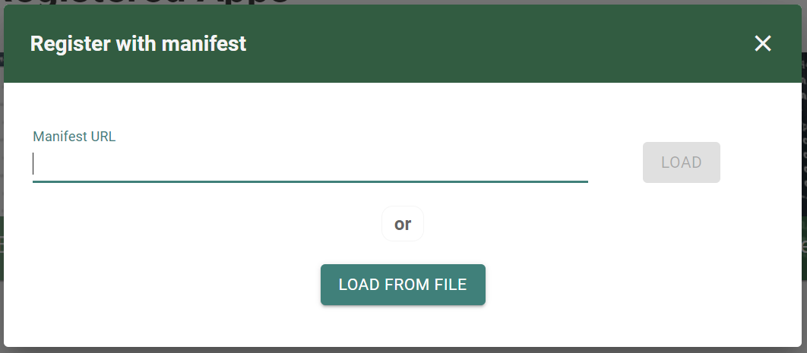

Enter the base URL of your hosted application. The hosted app must meet these criteria:

1. Contains .well-known/smart/manifest.json at the Base URL path
2. Is hosted on HTTPS
3. Contains proper CORS headers

Additionally, you can also load from a file if you choose not to use a URL.

## Bilirubin Risk Chart Application

The Bilirubin Risk Chart is a SMART on FHIR app based on Intermountain Healthcare’s HELP2 Bilirubin app. This app is for demonstration purposes only and is not approved for clinical use.

Jaundice occurs in most newborn infants. Most jaundice is benign, but because of the potential toxicity of bilirubin, newborn infants must be monitored to identify those who might develop severe hyperbilirubinemia and, in rare cases, acute bilirubin encephalopathy or Kernicterus. Although kernicterus should almost always be preventable, cases continue to occur.

By overlaying bilirubin [Mass/volume] results over a time-based risk chart, clinicians are presented with a visual representation of the results and associated criticality zones. By viewing the results in this way, the clinician can determine the best course of action based on the recommended intervention for the criticality of the result.

To launch the Bilirubin risk chart app, select it on the Apps page. Use the Launch button to open the App. Prior to opening, you will be prompted to select the Persona who is “using” the application and the patient data which will be pulled.

## CDS Hooks Application

Select the CDS Hooks Application from the Apps page.

Once you have selected Launch, you will need to select the Persona using the application and the Patient whose data is being used.

The App will then launch and the user can adjust the fields as necessary.

## EHR Simulator

The EHR Simulator in the Meld Sandbox allows users to visualize SMART on FHIR Applications in a simulated EHR format. Applications which have been added into the sandbox (Manually/Through A Manifest) will appear in the EHR Simulator for use.

Navigate to the EHR Simulator using the Navigation Bar on the left side of the sandbox, after clicking on the EHR Simulator Button you will be prompted to select the Persona who is viewing the EHR. You will also need to select the Patient whose data is being viewed.

Demographic information for both the Patient and Persona will appear along the top bar in the EHR Simulator. The user can then select an application from the left navigation bar to display patient data.

## Registering a CDS Service

To register a new CDS Hooks Service to your sandbox instance, navigate to the CDS Hooks page and click the Create (+) button. This will prompt you to enter the Service Name and Service URL. Once these fields have been populated, the CDS Service will appear in your sandbox.

## Launch Scenarios

A sandbox launch scenario is used to simulate a clinical use case or situation. A sandbox launch scenario is used to execute a particular launch flow described in the SMART on FHIR specification.

**How to create a Launch Scenario**

Step 1: Select App or CDS Service

A launch scenario can be created for use with a SMART on FHIR application or a registered CDS service within the sandbox. When creating the launch scenario, you will need to select either the Application or CDS service option.

* If you select SMART App, you will be prompted to select one of the SMART Apps registered in your sandbox.
* If you select CDS Service, you will be prompted to select one of the CDS services registered in your sandbox.

Step 2: Select the Persona (user) in the scenario

The scenario is used to simulate a real-world actor in the launch scenario. So, you must first select who the Application or CDS Service user is.

* If you select a Practitioner persona, then you are creating a scenario in which the practitioner is going to open an app and preform a function.
* If you select a Patient persona, then you are creating a scenario in which the patient is going into a PHR or patient portal to perform a function.

Step 3: Select the Patient in the scenario

If your real world scenario will expect a patient’s data to be present, you must select a synthetic patient to be an actor in your launch scenario. There are 2 ways to select a patient:

* You can type in the patient’s SMART id, which can be found on the patient tab.
* You can hit the search icon and select a patient from the list that will appear.

Step 4: Add Optional Information

Once you have completed the first 3 steps, you will have the ability to fill out a few more additional fields that may be relevant to your real world scenario. The following fields may be filled out:

* Encounter ID
* Location ID
* Resource
* Intent
* SMART Style URL
* Needs Patient Banner

These fields are not required but may add a more realistic feeling to your launch scenario.

Step 5: Save & Launch Your Scenario

Once you have filled out all the fields necessary to your launch scenario, you will need to select the save button. Once the Launch Scenario is saved, you will be able to run your launch scenario. Simply hit the play button and the launch scenario will run.

**How to Edit a Launch Scenario**

To Edit a Launch Scenario click on the icon with 3 dots, and click the edit option. This will allow you to edit any aspect of the Launch Scenario.

**How to use a Launch Scenario**

Once a Launch Scenario has been created, to run through a Launch Scenario simply hit the play button that is found on the Launch Scenario that you would like to run.

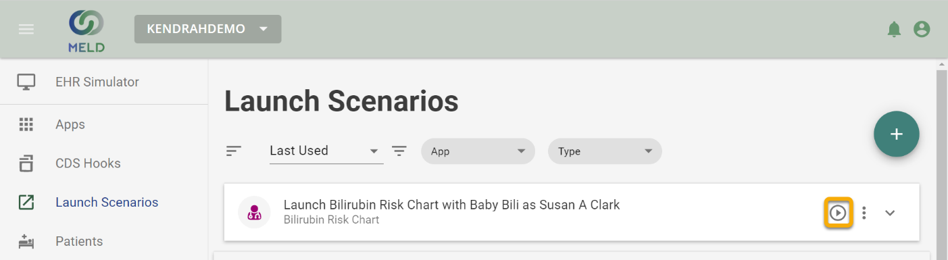

# Tools

The Tools section of the Meld Sandbox will link users to other Open Source FHIR tools like Crucible, ClinFHIR, Inferno, and the CDS Hooks Sandbox.

## Validation

Register a new Validation Package

The Meld sandbox has the ability to validate the synthetic resources against different FHIR Profiles. Before any validation can occur, the user must have uploaded a Profile (Either a .zip or through Simplifier.net) to the sandbox. Profiles can be uploaded on the Profile page.

The validation process can be done in four different ways:

1. Browsing—Select a FHIR Resource that is located within the sandbox
2. URI—Post the FHIR Resources URI
3. File—Upload a FHIR resource through a .zip file
4. JSON—Post the whole JSON body of a FHIR Resource

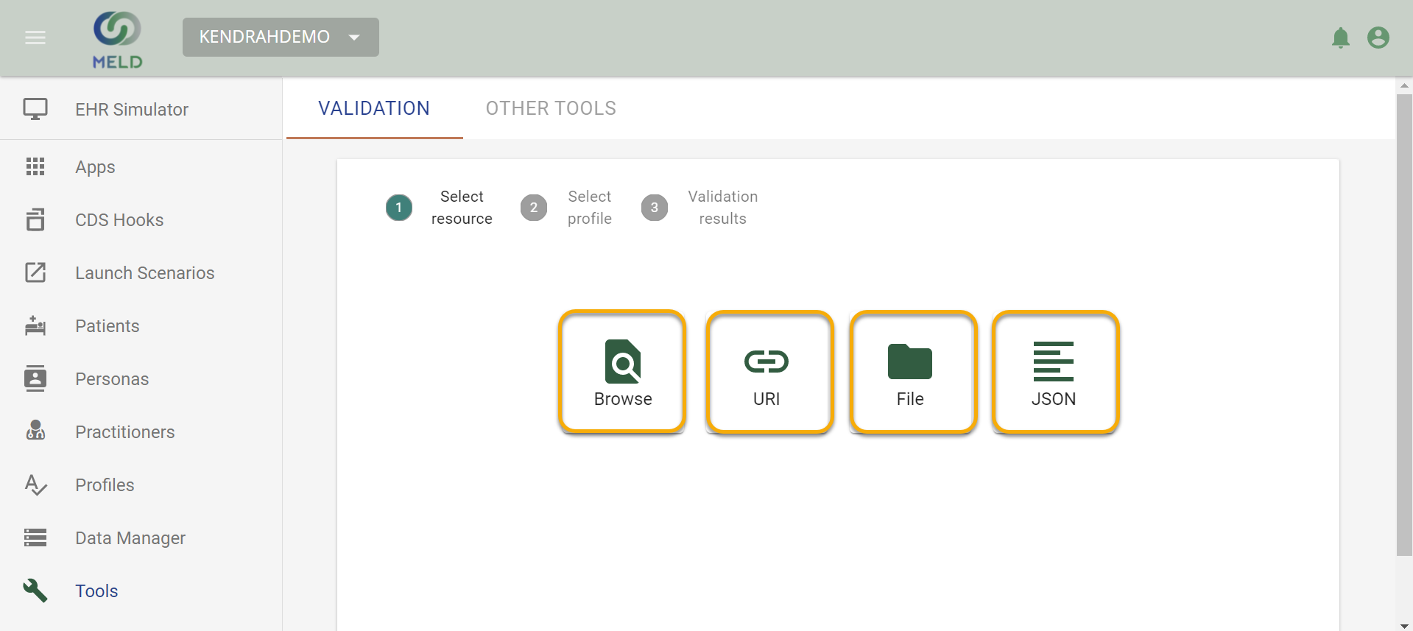

After selecting the FHIR resource you would like to validate, you will then need to select a Profile to validate it against. After selecting the Profile, Meld will begin to run the validation.

Once the validation is complete, it will show results in either JSON or Table form, with the user able to switch between the two views.

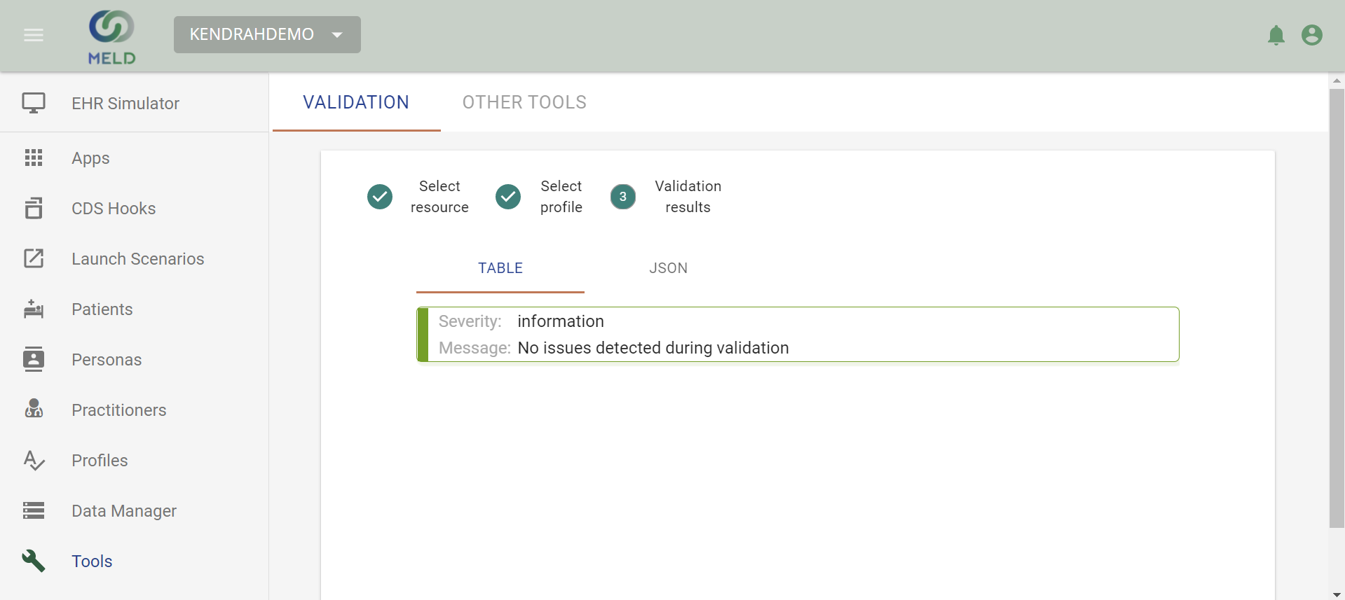

# Appendix: Terminology

|  |  |  |
| --- | --- | --- |
| Acronym | Term | Abbreviation |
| HL7 | Health Level Seven | A set of international standards used to provide guidance with transferring and sharing data between various healthcare providers |
| FHIR | Fast Healthcare Interoperability Resources | A standard describing data formats, elements, and an application programming interface for exchanging electronic health records |
| HAPI FHIR | Fast Healthcare Interoperability Resources | A complete implementation of the HL7 FHIR standard for healthcare interoperability in Java |
| Sandbox |  | A testing environment that isolates untested code changes and outright experimentation from the production environment or repository in the context of software development including Web development, Automation, and revision control |
| CDS Hooks | Clinical Decision Support Hooks | A specification that describes the RESTful APIs and interactions to integrate CDS Support between CDS Clients and CDS Services |
| Validation |  | The process of establishing documentary evidence demonstrating that a procedure, process, or activity carried out in testing and then production maintains the desired level of compliance at all stages |
| Inferno |  | A testing suite for HL7 FHIR to help developers implement the FHIR standard consistently |
| ClinFHIR |  | An open-source testing tool that provides an educational environment and also allows developers to create or search for FHIR based resources |
| Crucible |  | A suite of open-source testing tools for HL7 FHIR. It is provided as a free service to the FHIR development community to help promote correct FHIR implementations. It currently can test for conformance to the FHIR standard, score patient records for completeness, and generate synthetic patient data |
| Persona |  | A user used for authenticating when launching an app. A persona is tied to either a Practitioner or Patient FHIR Resource |